COMP2001 – Coursework1

**Exercise 1:** Normalization

Difficulty and Route type could be assumed as repeating groups due to trails usually being “easy, medium or hard” and “loop, out and back, point to point”. However, this could change on occasion so its easier to keep these attributes within the trail table. Features is a repeating group however, so had to be split into a separate group. This created a many – many relationship so a junction table had to be added.

**Exercise 2:** Entity Relationship Diagram

Partial ERD Diagram

The users included in the initial ERD has been removed as it is going to be pulled through an API. Meaning that the data does not need to be stored in the database. However, the users will have specific access to view a trail (user) or create a trail (admin) which will be decided through roles on the trail microservice.

The partial ERD shows the many to many relationship between the Trail and Features.

Final ERD

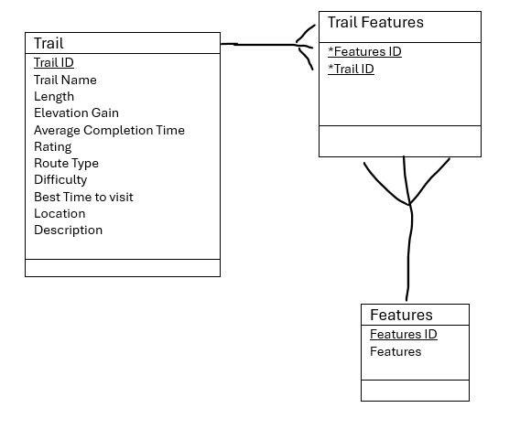

The final ERD shows the many – many relationship has been resolved by creating a junction table called “Trail features”. This ERD will be implemented into the database.

**Exercise 3:** Database Design

**Appendix**

Initial ERD Diagram

